**Daily Scrum or Standup Meeting**

Team name: _______Group 2________________

Scrum Master: ______Emily Thomas__________

Date:_______10/6________________________

| **Team Member** | **What did you do since the last scrum?** | **What do you plan to do before the next scrum?** | **What obstacles do you have?** |
| --- | --- | --- | --- |
| Emily Thomas | Set up model / view for managing inventory | Set up model / view for editing inventory and storing changes in database | I’ve never made edits to a database item in Django before |
| Andre Nguyen | Started and implemented add drink method | Wrap up the add drink method and start the remove drink method | Midterms, Django learning Gap |
| Maris Hurst | Tried to update README.md with instructions to run the hifi prototype | Copy User Auth into project and add functionality for multiple user types | Time, weird computer problems (ie not understanding where django is installed etc) |
| Karl Poulson | Started creating multiple views based on diagrams | Finish login and drink view prototypes | Css positioning and styling |
|  |  |  |  |

# Burndown

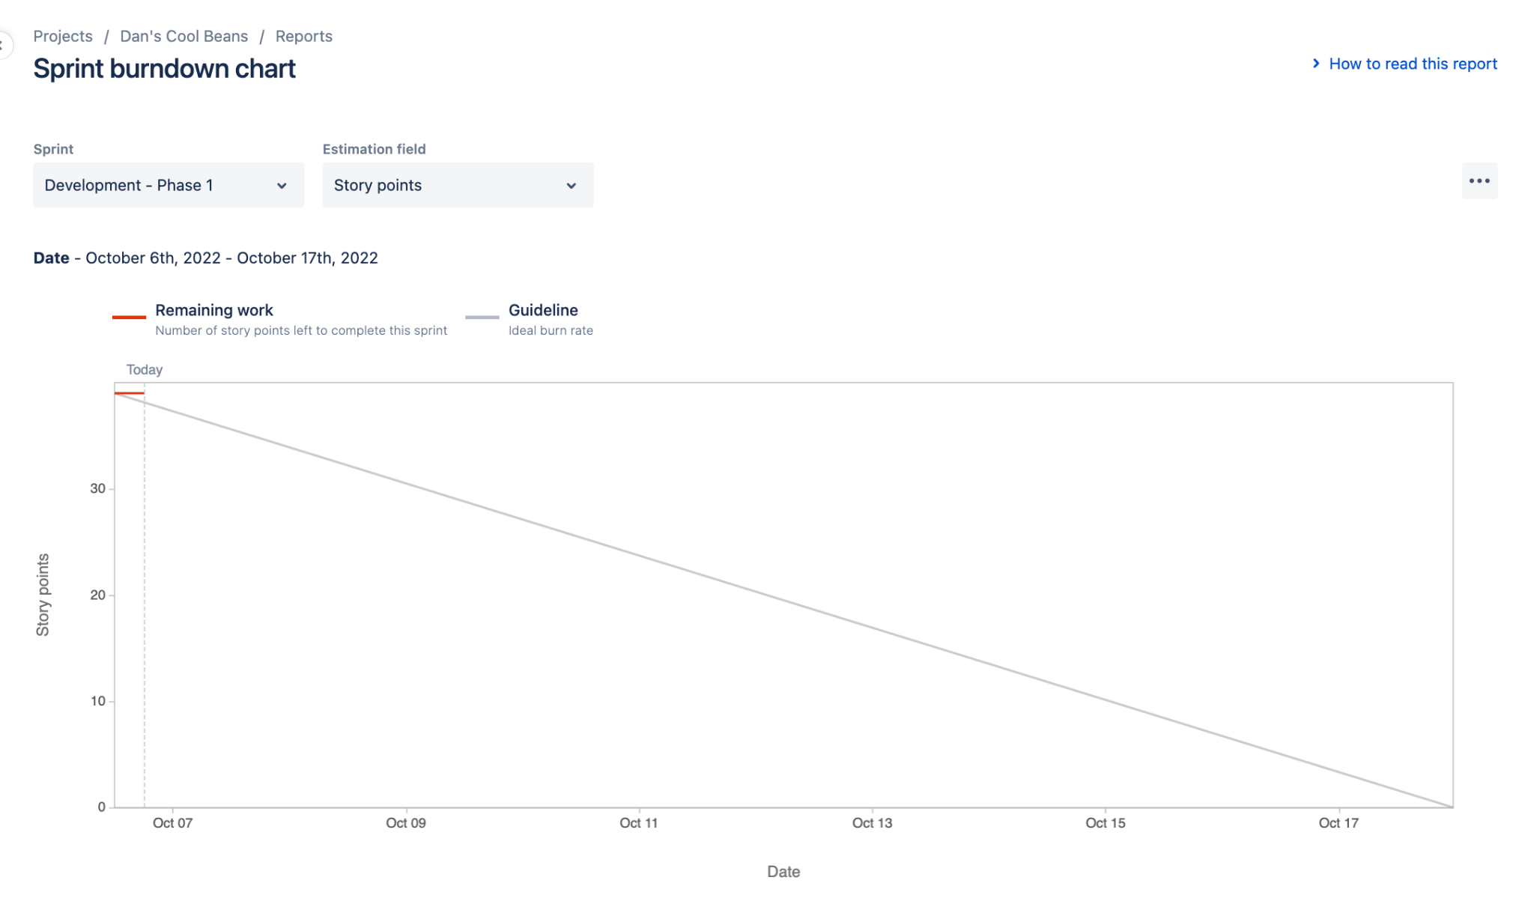

# Screenshot of you project board

